M.Jean-Pierre and Sahib jabbal

University of Kent

[Company address]

Unit testing and UI tests for iteration 3

BuzApp Project Specification

|  |  |  |  |
| --- | --- | --- | --- |
| Version Control | | | |
| Version | Author | Comments | Date |
| V1 | Marc Jean-Pierre | First Version of Document | 23/03/18 |
| QA1 | Sahib Jabbal | Reviewed the Document | 24/03/18 |

**BuzApp Unit Tests and UI Tests for Iteration 3**

**Unit Test Results**

The illustration below shows the unit test results after testing were successful.

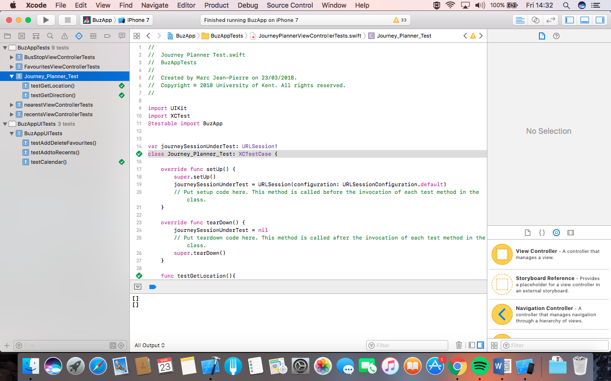

**UI Test Results**

****The illustration shows below the user interface test results after testing were successful.